OUTFIT RENTAL SYSTEM

Our Project, Outfit Rental System consists of 5 tables.

1. Outfit Table
2. Customer Table
3. Rental Table
4. Return Table
5. Users Table

Let’s go through each table and know the attributes in it.

**OUTFIT TABLE**

This table consists of 5 attributes. Namely, DressCode, Brand, Type, Availability and Price.

* **DressCode** is Varchar (50) datatype containing no null values and this is the primary key of the table. This is a unique ID which will be given to the outfit.
* **Brand** is a Varchar (50) datatype containing no null values. This describes the brand of the outfit. For example, some of the brands are CK, TheNorthFace, Nike, etc.
* **Type** is a Varchar (50) datatype containing no null values. This describes the type of the outfit, whether it is a Hoodie, Shirt, Trouser or Shoes, etc.
* **Availability** is a Varchar (50) datatype containing no null values. This is a choice answer whether the outfit is available or not. If the outfit is available, it takes "Yes", else if it not available, it takes "No".
* **Price** is a Varchar (50) datatype containing no null values. This is the amount of the outfit given for rent per day.

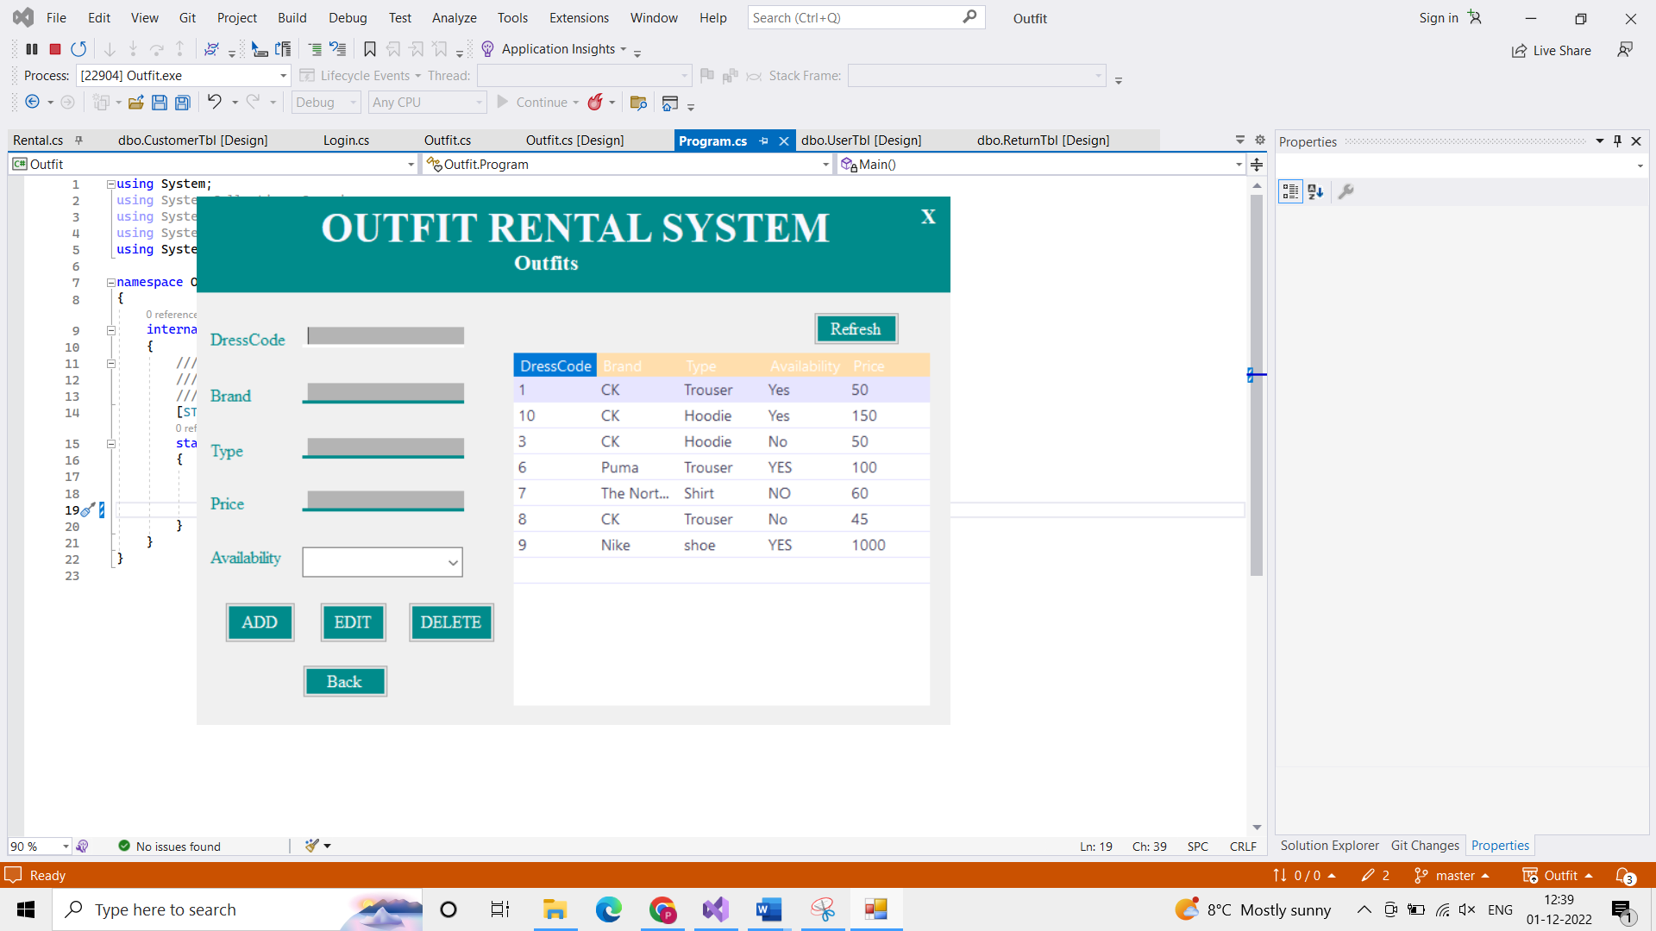

**OUTFIT (**DressCode, Brand, Type, Availability, Price**)**

**Foreign Key:- The** DressCode acts as foreign Key.

**Functional Dependencies: -** DressCode 🡪 Brand, DressCode 🡪 Type, DressCode 🡪 Availability, DressCode 🡪 Price

**Closures: -**

{DressCode}+ = {DressCode, Brand, Type, Availability, Price}

{Brand}+ = {Brand}

{Type}+ = {Type}

{Availability}+ = {Availability}

{Price}+ = {Price} etc…

**Keys: -** DressCode.

**Nontrivial Dependencies: -** DressCode 🡪 Brand, DressCode 🡪 Type, DressCode 🡪 Availability, DressCode 🡪 Price

“For the above Nontrivial Dependencies, All the keys are in the left side. Therefore, the relation Outfit is on 3NF.”

**CUSTOMER TABLE**

This table consists of 4 attributes. Namely, Customer Id, Customer Name, Customer Address, and Customer Phone Number.

* **Id** is int datatype containing no null values and this is the primary key of the table. This is a unique ID which will be given to the customer.
* **Name** is a Varchar (50) datatype containing no null values. This is for knowing the Customer name.
* **Address** is a Varchar (50) datatype containing no null values. This is for knowing the Customer address.
* **Phone** is a Varchar (10) datatype containing no null values. It takes only 10 digits. This is for knowing the customer’s phone number.

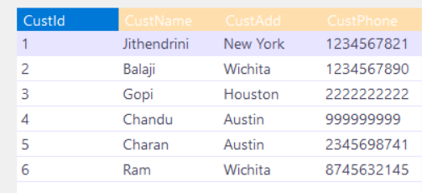

**CUSTOMER (**CustId, CustName, CustAdd, CustPhone**)**

**Foreign Key:- The** CustPhone acts as foreign Key.

**Functional Dependencies: -** CustId 🡪 CustName, CustId 🡪 CustAdd, CustId 🡪 CustPhone, CustId, CustName 🡪 CustAdd, CustId, CustName 🡪 CustPhone, etc---

**Closure**: -

{CustId }+ = { CustId, CustName, CustAdd, CustPhone}

{ CustName }+ = { CustName }

{ CustAdd }+ = { CustAdd }

{ CustPhone }+ = { CustPhone, CustId, CustName, CustAdd }

{CustId, CustName}+ = { CustId, CustName, CustAdd, CustPhone} etc……

**Keys**: - CustId, CustPhone

**Nontrivial Dependencies: -** CustId 🡪 CustName, CustId 🡪 CustAdd, CustId 🡪 CustPhone, CustId, CustName 🡪 CustAdd, CustId, CustName 🡪 CustPhone etc…..

“For the above Nontrivial Dependencies, All the keys are in the left side. Therefore, the relation CUSTOMERis on 3NF.”

**RENTAL TABLE**

This table consists of 6 attributes. Namely, Id, DressCode, Customer Id, Name, Rental Date, Return Date, and Fees.

* **Id** is a int datatype containing no null values and it is the Primary key of the table. This is the unique Id for rent.
* **OutfitReg** is a Varchar (50) datatype containing no null values. This is the Outfit Id. This is the foreign key from Outfit table Id.
* **Name** is a Varchar (50) datatype containing no null values. This is for knowing the customer’s Name.
* **RentDate** is a date datatype containing no null values. It is for recording the date on which the customer took the outfit for rent.
* **ReturnDate** is a date datatype containing no null values. It is for recording the date on which the customer returned the outfit which they took for rent.
* **RentFee** is the int datatype containing no null values. This is the value of amount for which the outfit is given for rent.

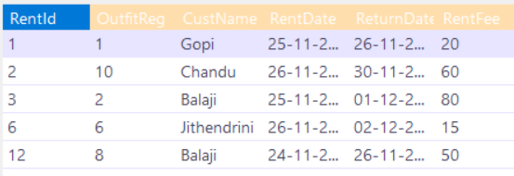

**RENTAL (**RentId, OutfitReg, CustName, RentDate, ReturnDate, RentFee**)**

**Foreign Key:- The** RentId acts as foreign Key.

**Functional Dependencies: -** RentId 🡪 OutfitReg, RentId 🡪 CustName, RentId 🡪 RentDate, RentId 🡪 ReturnDate,

RentId 🡪 RentFee etc…

**Closure**: -

{ RentFee }+ = { RentId, OutfitReg, CustName, RentDate, ReturnDate, RentFee }

{ OutfitReg }+ = { OutfitReg }

{ CustName }+ = { CustName }

{ RentDate }+ = { RentDate }

{ RentFee }+ = { RentFee } etc……

**Keys**: - RentFee

**Nontrivial Dependencies: -** RentId 🡪 OutfitReg, RentId 🡪 CustName, RentId 🡪 RentDate, RentId 🡪 ReturnDate,

RentId 🡪 RentFee etc…..

“For the above Nontrivial Dependencies, All the keys are in the left side. Therefore, the relation RENTALis on 3NF.”

**RETURN TABLE**

This table consists of 6 attributes. Namely, ReturnId, OutfitReg, CustomerName, Return Date, Delay and Fine.

* **ReturnId** is an int datatype containing no null values and it is the Primary key of the table. This is the unique Id for recording the return outfit.
* **OutfitReg** is a Varchar (50) datatype containing no null values. This is the Outfit Id. This is the foreign key from Outfit table Id.
* **CustomerName** is a Varchar (50) datatype containing no null values. This is for knowing the customer’s name.
* **ReturnDate** is a date datatype containing no null values. It is for recording the date on which the customer returned the outfit which they took for rent.
* **Delay** is the varchar (50) datatype containing no null values. This is for knowing the number of days past the recorded return date.
* **Fine** is the int datatype containing no null values. This is the value of amount for which the outfit is given for rent and on delay days.

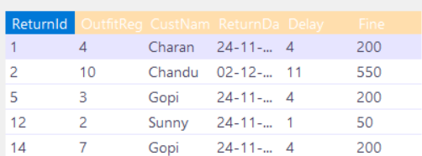

**RETURN (**ReturnId, OutfitReg, CustomerName, ReturnDate, Delay, Fine**)**

**Foreign Key:- The** ReturnId acts as foreign Key.

**Functional Dependencies: -** ReturnId 🡪 OutfitReg, ReturnId 🡪 CustName, ReturnId 🡪 RentDate, ReturnId 🡪 Delay, ReturnId 🡪 fine etc…

**Closure**: -

{ ReturnId }+ = { ReturnId, OutfitReg, CustomerName, ReturnDate, Delay, Fine }

{ OutfitReg }+ = { OutfitReg }

{ CustName }+ = { CustName }

{ RentDate }+ = { RentDate }

{ Delay }+ = { Delay } etc……

**Keys**: - ReturnId

**Nontrivial Dependencies: -** ReturnId 🡪 OutfitReg, ReturnId 🡪 CustName, ReturnId 🡪 RentDate, ReturnId 🡪 Delay, ReturnId 🡪 fine etc…

“For the above Nontrivial Dependencies, All the keys are in the left side. Therefore, the relation RETURNis on 3NF.”

**USER TABLE**

This table consists of 3 attributes. Namely, Id, User name, and User Password.

* **Id** is an int datatype containing no null values and it is the Primary key of the table. This is the unique Id given to the user.
* **Uname** is a Varchar (50) datatype containing no null values. This is for the name of the user.
* **CustomerName** is an int (5) datatype containing no null values. This is for the users password through which they can login. Table

  Description automatically generated